Chapter 7: Initial Data Assessment

Components

- Column profiling
- Structure profiling
- Production of deliverables from an initial assessment

Assessment Scenarios

“The general purpose of data quality assessment remains the same: to understand the condition of data and to draw a conclusion about its impact in relation to expectations or particular purposes or both.” (95)

A need for continual review (e.g. as a source updates its data, the assessment should be run again and compared with previous assessments)
- “Initial assessment provides metadata that is the foundation for other assessments. To ensure this foundation is firm, you should plan from the beginning to systematically and consistently capture findings” (98)

Particular aspects of data in need of quality monitoring may be selected as a place needed for focus in the assessment

An Ongoing Process for Future DQ Considerations

“Initial data assessment produces valuable metadata (including specific baseline measurements) about the content, structure, and condition of the data being assessed. One goal of an initial assessment is to produce a set of recommendations for data quality improvement and for ongoing measurement and control.“ (97)

Good Advice

“As part of the analysis, you should also identify which data elements and rules appear to be most critical and most at risk. As you investigate questions raised by the assessment, you should actively seek input from business users about data criticality.” (98)

Initial Assessment

Data Expectations
- Producer expectations vs. Consumer expectations
- “It is important to identify the expectations of both data producers and data consumers since these likely differ and identifying such differences is necessary to resolving them.” (100)

Data Standards
- “Data quality standards are assertions that relate directly to quality dimensions. Standards for a given system should cohere. One of the outcomes of an assessment might be to identify contradictory standards. Standards should also be measurable. Another outcome of an assessment might be to associate specific measurements with data that is expected to conform to standards.” (99)

Data Profiling

Column Property Profiling

- Identifying data type, length, format
- Distribution analysis
  - “Percentage calculations also help in identifying other relationships within the data. Columns that have similar distributions may have a dependent relationship on each other, for example.” (100)
  - “Each column should have a defined domain of values” (101)
  - Inspecting high frequency and outlier values for interest/expectation/errors
- “cardinality of the column (distinct number of values)” (102)
- “percentage of defaulted records” (102)
- “number of data format patterns for each column” (102)
- Baseline expectations from prior source metadata if possible
  - If not available then you rely on intuition/common sense “to confirm both your actual findings and your assessment of their implications” (102)
- Column qualities to observe
  - Validity
  - Completeness
  - Consistency
  - “The presence of values that are not identified as valid values.”
  - “Cardinality different from expected (high cardinality where low is expected or low cardinality where high is expected).”
  - “Less-than-complete population of a column where you expect complete population.”
  - “The presence of multiple data patterns in one column.”
- Invalid Values
  - “Validity and domain rules are a form of data expectation. If you know nothing about a column except its valid values, you can still draw some conclusions about the quality of the data based on a distribution analysis of those values.” (102)
  - The absence of valid values
  - Unusual cardinality - requires an investigation of column’s status
    - Cardinality of one
    - High cardinality (all unique, multiple data sources with different value sets)
    - A column being used for multiple purposes
    - Mislabeled columns
    - Problem with the data source
  - “When two fields have the same exact cardinality, they should be compared. They may contain redundant data.” (104)
- Columns with Less-Than-Complete Population
  - “Under what conditions is the column expected to be populated, and under what conditions is it not expected to be populated?” (104)
  - “Knowing and documenting these conditions can also help in the investigation of dependency rules and other data relationships.” (104)
  - Possibility of multiple default values depending on how they were entered by source - defined default vs functional default
    - The reason for that multiplicity should be investigated
- Multiple Data Format Patterns in One Column

Structural Profiling

- Referential Integrity
  - “If all records on the child table do have references on the parent table, then referential integrity exists between the two tables. This relationship is sometimes called an inheritance rule.” (106)
  - Valid domains/validity of data value (ranges)
  - Data completeness with regards to referential integrity
    - “The presence or absence of orphan records can be used as a measure of completeness. These relationships also depend on data consistency.”
  - Things to look for:
    - Missing references
      - Parentless children
      - Childless parents
    - Misdiagnosing problems that seem to exist in the ‘sample’ data but do not exist in the ‘production’ (or total) data
      - Or vice-versa, problems exist in the full set that do not exist in the sample set
- Dependency Relationships
  - Positive or mutually dependent (a relationship that requires the presence of information)
  - Negative or mutually exclusive (a relationship that prohibits the presence of information)
  - Conditional relationships
    - Often more work to describe, and if not known ahead of an assessment hard to identify
  - Things to Look for
    - Dependency relationships that are absent when expected or present when not expected
    - “It may be that the attributes represent something different from what the metadata indicates they do. Or that analysis has identified a business rule that no one had explicitly described before. Discovery of such rules and relationships is one of the benefits of profiling data. It is critical to document such discoveries so that this knowledge can be shared.” (107)
    - “dependency rules provide insight into data consistency, as well as validity and completeness.” (108)
- Differences in Granularity and Precision
  - “Across such systems, it is not unusual that data representing the same concept is presented at different levels of grain or different levels of precision.” (108)
  - Granularity
    - “Granularity refers to the degree to which information is represented by constituent parts. A simple illustration can be made with phone numbers.” (108)
    - Challenge for granularity is with how more complex concepts are represented by the data
  - Precision
    - “precision refers to how fine the data is in a given field.” (108) or “fineness of measurement” (108)
      - Fields can have similar granularity but different precision (“the sets of valid values offer different degrees of precision”) (108)
    - What to look for:
      - “Instead, as part of the initial assessment of data, you should identify the fact that data representations differ, and then you should define the specific ways they differ from each other. These differences represent risk because they break the expectation for similarity between data representing the same concept and because integrating data of different granularity requires developing a data model that can appropriately accommodate the differences.” (108)
- Relationship Cardinality
  - “the ways in which entities can be related to each other” (109)
  - 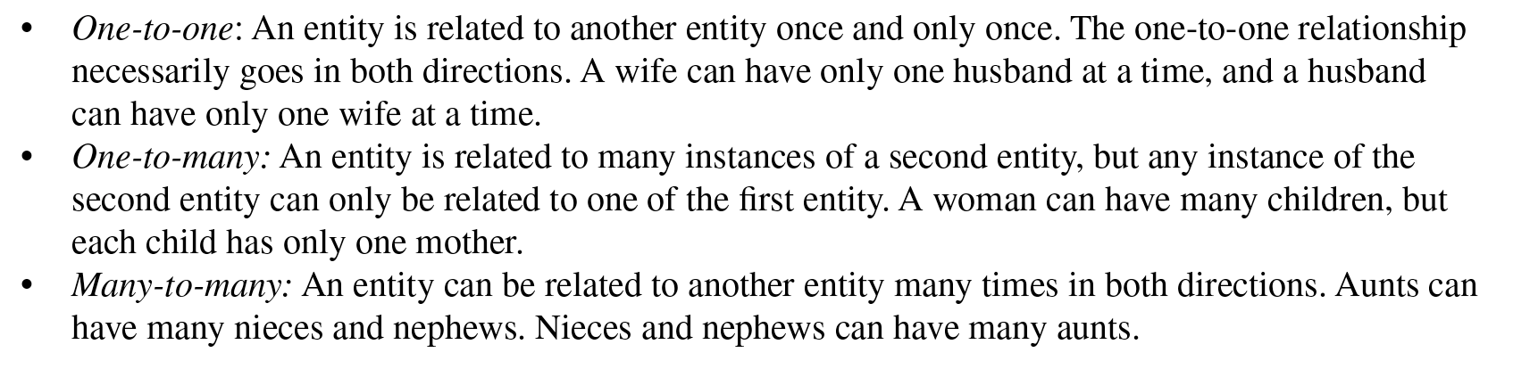
  - Also, cardinality of relationships can be put in terms of optionality
  - 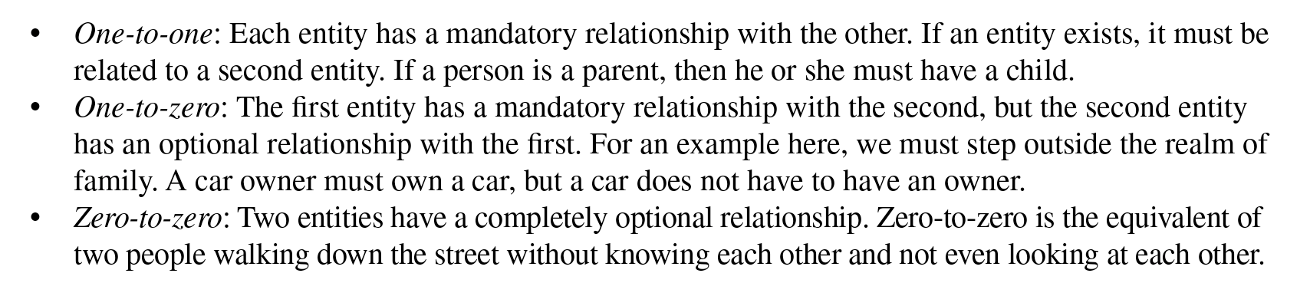
  - “Assertions about the cardinality of relationships are a form of expectation about data. If there are differences between the cardinality you expect and the cardinality that exists in the data…then you should determine the reasons for the differences and their impact on uses of the data” (109)

Goals of an Initial Assessment include the creation of a data model and a data dictionary
- “As most people who work in data management know, few data stores will have metadata that perfectly reflects the condition of the data. A more likely scenario is that profiling will result in the detection of unexpected conditions in the data and gaps or inaccuracies in the metadata or both.” (110)

From Profiling to Assessment
- “Profiling will produce a set of facts about data, but it does not, in and of itself, constitute assessment. To be meaningful, assessment requires comparison. To characterize the quality of data, you need to compare the facts you have discovered up against expectations about the data and draw conclusions about how well the data meets those expectations.” (110)
- Expectations and adherence for audiences
  - “Profiling will produce a set of facts about data, but it does not, in and of itself, constitute assessment. To be meaningful, assessment requires comparison. To characterize the quality of data, you need to compare the facts you have discovered up against expectations about the data and draw conclusions about how well the data meets those expectations.” (110)

Deliverables from Initial Assessment
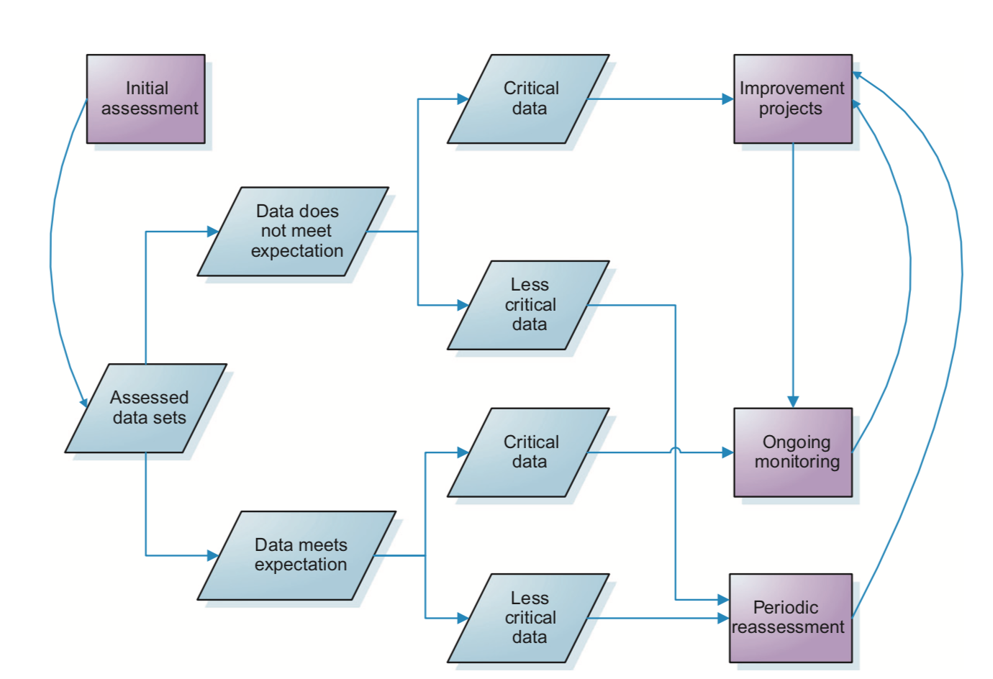
“The primary goal of initial assessment is to characterize the condition of the data you are assessing. From input gathered during the process, you should also have a clear understanding of which data is most critical to your organization. Usually, assessment is directly connected to a project. Projects may include building a data store, integrating new data into an existing one, or, analyzing the condition of existing data for purposes of identifying improvement opportunities. Some criteria for quality should be associated with project goals.
“The primary deliverables from an initial assessment are a summary of assessment results: the measurements that were taken against the data and the degree to which the data conform to expectations (whether those expectations are general or in the form of requirements or standards). The results summary should also identify opportunities for improvement, recommendations for data standardiza- tion, and recommendations for ongoing measurement and control. Opportunities for improvement and standardization can be identified for individual data elements, data rules, the data model, or meta- data and references data (see Figure 7.3). Recommendations for ongoing measurement should not only describe how data should be measured; they should also include an assessment of the criticality of any data elements or rules to be measured. Recommendations for controls should describe how to reduce risks associated with source data or data processing.
“Output from the initial assessment will also include valuable metadata; for example, improved definitions of data elements, documented business processes, and documented understanding of tech- nical processes. This metadata is also required as input for ongoing measurement and control.” (110-111)

